Week 2 Final Report – System Design & Architecture

1. Introduction
During the second week, the focus was on designing the system architecture and defining the key modules of the proposed project. This stage was crucial in transforming the project requirements gathered in Week 1 into a clear, structured, and technically feasible system design.

2. Activities Completed

a. System Architecture
A block diagram was prepared to represent the interaction between the User, Chatbot (Bot Engine), Database, and Map API. The architecture ensures smooth communication from the user interface to the backend database and navigation services.
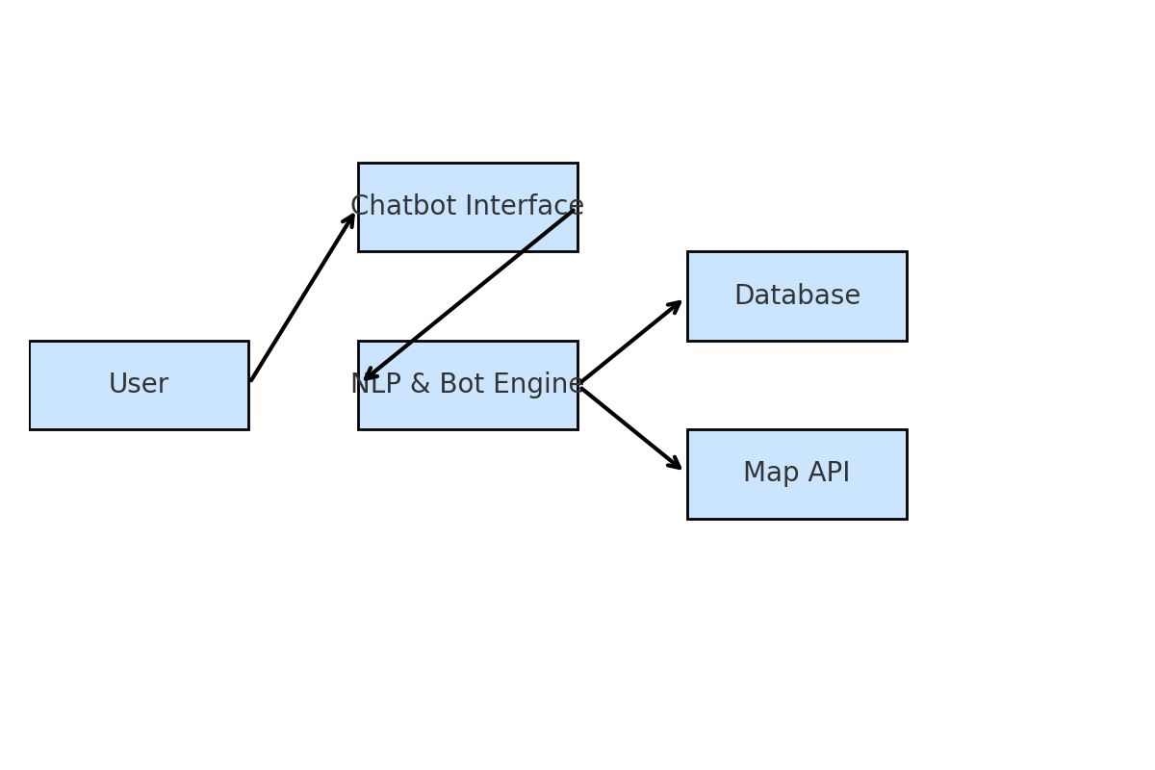

b. Module Definition
The system was divided into the following modules:
1. User Interface – Chatbot interface for user interaction.
2. NLP & Bot Engine – Processes and understands user queries (FAQs, navigation).
3. Navigation/Pathfinding – Provides directions using Google Maps API or campus maps.
4. Database – Stores and retrieves campus details, events, staff information, and FAQs.
The key features finalized for the project are:
- Interactive Chatbot for campus-related queries.
- Natural Language Processing (NLP) to understand user intent.
- Navigation support using Google Maps API or predefined campus maps.
- Database connectivity for retrieving staff, events, and FAQs.
- Real-time response generation for smooth interaction.
- User-friendly interface accessible on web and mobile platforms.

b.1 Features of the System

c. Database Schema Design
Designed tables for:
- Locations (buildings, classrooms, hostels, library, etc.)
- Events (campus activities, schedules)
- Staff Details (faculty, administration)
- FAQs (predefined common queries)
The schema was structured to support quick data retrieval and easy integration with the chatbot.

d. Methodology Drafted
The Methodology section of the project synopsis was written. It explains how different modules will work together, from user input to response generation, supported by NLP, database queries, and navigation APIs.

3. Deliverables Submitted
- Completed System Architecture Diagram and Block Diagram.
- Defined Modules and Features for the project.
- Drafted Database Design (schema and tables).
- Added Methodology Section to the project synopsis.

4. Conclusion
By the end of Week 2, the system design and architecture were finalized. This provides a strong foundation for Week 3, where the focus will shift towards development and implementation of the chatbot prototype and integration with the database and navigation services.

